Course code: ZOO 636
Course name: Aquaculture & Fisheries
Teacher: Ms Prabhjot Kaur
Dept.: Zoology
Topic: Hilly stream Fishes & their adaptations
A number of fishes migrate from sluggish water of lower streams to colonize in the torrential waters of the upper streams. These migrations were chiefly in search of food and the shelters from the predators. In these new habitats fishes adapt to hill stream environment.
Environmental conditions of the hill stream:
- Strength of water currents: It appears to be the primary factor in the evolution of hill stream fishes. The water moves predominantly in one direction in hills, causing both, the lesser stability of bottom materials as well as the erosion.
- Light Intensity: The sun rays in hill streams penetrate deep into water because it is shallow and very clear owing to absence of suspended particles. Fishes, therefore, have to adopt either to withstand the intense light or to shelter themselves under the rocks or stones.
- Dissolved Oxygen: The water is well aerated with plenty of oxygen due to rapid rate of flow of water. Abundance of oxygen is therefore, a favourable condition to fishes inhabiting the torrential streams
- Temperature: The temperature of hill streams fluctuates rapidly but remains more or less constant from surfaces to the bottom. The water is generally cooler but get heated by sun
- Availability of Food: Good amount of food is available in the hill stream but is in the form of algae covering stones and rocks. Fishes, therefore, have to largely depend upon the algal filaments. In certain regions the microbes and the insect’s larva may also become available to the fishes.
The important fishes of hill stream belong to several genera of three families of order cypriniformes: Balitoria, Barbus (Tor), Garra, Labeo, Schizothorax, Glyptothorax, Pseudochensis, Botia etc.
Adaptive modification in hill stream fishes:
Structural modifications which the hill stream fishes have developed to adapt to the environment are as follows:
- Shape: Hill stream fishes are usually have flattened head and body in contrast to cylindrical bodies of fishes found in tanks and lakes. Example is Balitoria, their flattened ventral surface permit no water to escape under them and so prevent them from being swept away with the fast water current. The head of hill stream fishes is generally semi-circular
- Size: Hill stream fishes are generally small in size, have short and thicker bodies and semicircular heads. Their small size permits them to hide under the rocks & stones during the intense sunlight and prevents from being crushed under the rolling stones
- Scales and bony armour: It is poorly developed. Absence of scales from ventral side also makes the ventral surface smooth for attachment on the rocky bottom
- Mouth: Instead of being a transverse cleft at the anterior end of snout it is shifted towards the ventral side, behind the tip of snout.
- Barbels: They are specialised, greatly reduced being short and stumpy as in Balitora
- Eyes: They are usually small in size and are pushed toward the upper surface of head (protective measure against sunlight & to free the ventral surface for attachment) as in Balitora, Glyptothorax, Glptosternum .
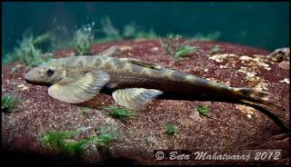
Balitora
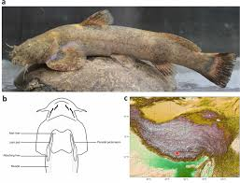
Glptosternum
- Fins: fins are used as organs of locomotion & attachment. To perform dual function various modifications in structure of fins persists which are as follows:
- Paired fins: In Garra both pectoral pelvic fins are set low on the body to provide greater friction against rocks and stones. In Astroblepus choate they forms sucker, which along with sectorial mouth is used to climb over vertical rocks and water fall. In many hill stream fishes, outer rays of paired fins are modified for adhesion, they become thick and flat.
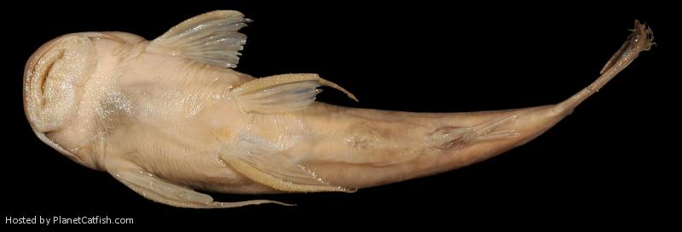
Astroblepus choate climbs up the pitholes
- Caudal fin and its peduncle: Hill stream fishes possesses a long, narrow, muscular band shaped caudal peduncle as in Glptothorax straitus, Balitoria, it is adaption for life at high altitudes and rapid flowing water. Lower lobe of caudal fin is long as compared to upper one as in Glyptothorax, Garra, Balitoria etc
- Pectoral & Pelvic Fins: These are also modified particularly in those species in which fins are used for adhesion. In Glyptothorax and Pseudoecheneis various bones of pectoral gill openings girdle are fused to provide strength. Keel like ridges are present on the ventral surface of the inter-clavicular bone , to provide surface for attachment to their muscles. The ridges are generally elevated posteriorly ending in spine like processes. Adductor and abductor muscles attached to the girdles are better developed, also have more four type of muscles are developed to move the spine,
- Breathing apparatus: As the ventral surface is used for adhesion to rocks and stones, the gill slits lie on the sides and the gill chamber is specialised for retaining water for longer time. The restriction of the gill openings to the sides may effect respiration of fishes. But some factors helps in respiration. Firstly water in hills is well oxygenated. Secondly gill openings are small, the fish is able to retain water in the branchial chamber for longer time. Thirdly the inner rays of the pectoral fins are kept in constant motion and helps in respiration by forcing the water in and out of the gill openings. The brancheostegal rays and membranes are greatly reduced in hill stream fishes
- Air bladder: It is reduced or degenerate in these fishes, because the buoyancy would be disadvantage in swift currents.
- Adhesive devices: One of the major problem of the fishes is to avoid being swept away in the rapid currents of mountain streams. For this the skin is variously modified to form adhesive organs. As in Glyptosternum and Pseudoecheneis bear a series of ridges on ventral surface of the body, which act as frictional devices. In Erethistes elongate, well developed striations are present on the chest and belly whereas genus Laguvia, striations are present on the chest only. In Glyptothorax, a well-developed U-shaped or V-shaped adhesive apparatus formed of folds of skin is present between the bases of pectoral fins. In Garra, the adhesive organ is in the form of disc behind the mouth
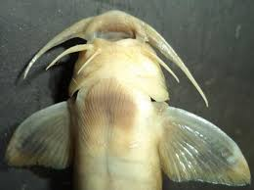xx
Glyptothorax showing adhesive pad
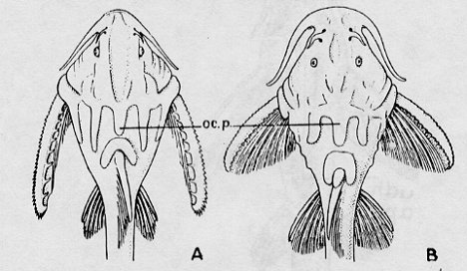
Laguvia & Erethistes

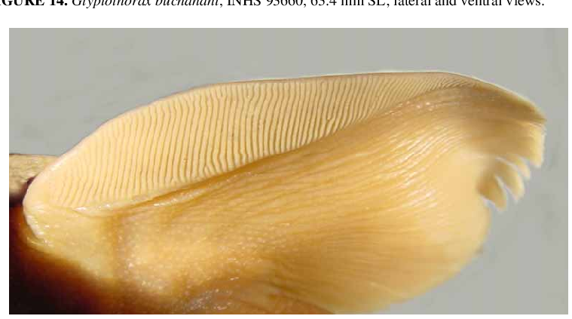
Adhesive organs on pectoral fin
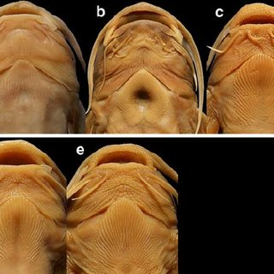
Thoracic adhesive apparatus of Glyptothorax

